# Homework 1

Henrik Lucander, 724140

## Problem 1)

$$x\left[k+2\right]-1.5x\left[k+1\right]+0.54x\left[k\right]=u[k\}$$

$$x\left[0\right]=x\left[1\right]=0$$

$$u\left[k\right]=\left\{\begin{matrix}1, & k=1 \\ 0, & k=0,2,3,4,…\end{matrix}\right.$$

## a)

z-transform the equation:

$${(z}^{2}X\left(z\right)-z^{2}x\left[0\right]-zx[1])-1.5(zX\left(z\right)-zx[0])+0.54X\left(z\right)=U(z)$$

$$U\left(z\right)=\sum_{k=0}^{inf}{u\left[k\right]z^{-k}}=u\left[0\right]z^{-0}+u\left[1\right]z^{-1}+u\left[2\right]z^{-2}+u\left[3\right]z^{-3}+u\left[4\right]z^{-4}+…$$

$$U\left(z\right)=\sum_{k=0}^{inf}{u\left[k\right]z^{-k}}=0z^{-0}+1z^{-1}+0z^{-2}+0z^{-3}+0z^{-4}+…=z^{-1}$$

Insert U(z) into equation:

$${(z}^{2}X\left(z\right)-z^{2}0-z0)-1.5(zX\left(z\right)-z0)+0.54X\left(z\right)=z^{-1}$$

$$X\left(z\right)\left(z^{2}-1.5z+0.54\right)=z^{-1}$$

$$X\left(z\right)=\frac{1}{z\left(z^{2}-1.5z+0.54\right)}=\frac{1}{z\left(z^{2}-1.5z+0.54\right)}=\frac{1}{z\left(z-0.9\right)(z-0.6)}$$

Partial fractions:

$$X\left(z\right)=\frac{1}{z\left(z-0.9\right)(z-0.6)}=\frac{A}{z}+\frac{B}{z-0.9}+\frac{C}{z-0.6}$$

$$A=\lim_{z→0}{\frac{1}{(z-0.9)(z-0.6)}=\frac{1}{0.54}}$$

$$B=\lim_{z→0.9}{\frac{1}{z(z-0.6)}=\frac{1}{0.27}}$$

$$C=\lim_{z→0.6}{\frac{1}{z(z-0.9)}=-\frac{1}{0.18}}$$

$$X\left(z\right)=\frac{\frac{1}{0.54}}{z}+\frac{\frac{1}{0.27}}{z-0.9}+\frac{-\frac{1}{0.18}}{z-0.6}=\frac{1}{0.54z}+\frac{1}{0.27\left(z-0.9\right)}-\frac{1}{0.18\left(z-0.6\right)} \\ X\left(z\right)=z^{-1}\left(\frac{1}{0.54}+\frac{z}{0.27\left(z-0.9\right)}-\frac{z}{0.18\left(z-0.6\right)}\right)=z^{-1}\left(\frac{1}{0.54}+\frac{1}{0.27}*\frac{1}{1-0.9z^{-1}}-\frac{1}{0.18}*\frac{1}{1-0.6z^{-1}}\right)$$

We can now take the inverse z-transform:

$$x\left[k\right]=\left\{\begin{matrix}0, & k=0,1 \\ \frac{1}{0.54}δ\left[k-1\right]+\frac{1}{0.27}{\left(0.9\right)}^{k-1}-\frac{1}{0.18}{\left(0.6\right)}^{k-1}, & k=2,3,4,…\end{matrix}\right.$$

$$δ\left[0\right]=1 and 0 otherwise:$$

$$x\left[k\right]=\left\{\begin{matrix}0, & k=0,1 \\ \frac{1}{0.27}{\left(0.9\right)}^{k-2}-\frac{1}{0.18}{\left(0.6\right)}^{k-2}, & k=2,3,4,…\end{matrix}\right.$$

## b)

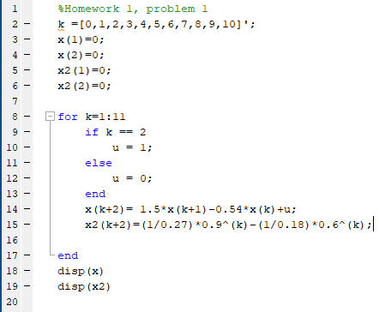

*m-code.*

which gives:

**with difference equation:**

**0 0 0 1.0000 1.5000 1.7100 1.7550 1.7091 1.6159 1.5010 1.3789 1.2578 1.1421**

**with the solution obtained in part a)**

**0 0 0 1.0000 1.5000 1.7100 1.7550 1.7091 1.6160 1.5010 1.3789 1.2578 1.1421**

## Problem 2)

$$y\left[k+2\right]-1.3y\left[k+1\right]+0.4y\left[k\right]=u\left[k+1\right]-0.4u[k]$$

## a)

$$u\left[k\right]=δ[k]=\left\{\begin{matrix}1, & k=0 \\ 0, & otherwise\end{matrix}\right.$$

z-transform (zero initial conditions):

$$z^{2}Y\left(z\right)-1.3zY\left(z\right)+0.4Y\left(z\right)=zU\left(z\right)-0.4U(z)$$

$${Y\left(z\right)(z}^{2}-1.3z+0.4)=U(z)(z-0.4)$$

$$G\left(z\right)=\frac{Y(z)}{U(z)}=\frac{z-0.4}{z^{2}-1.3z+0.4}$$

## b)

The system is stable if the poles are within the unit circle

$$G\left(z\right)=\frac{Y(z)}{U(z)}=\frac{z-0.4}{z^{2}-1.3z+0.4}=\frac{z-0.4}{(z-0.8)(z-0.5)}$$

**from the denominator we can see the poles 0.8 and 0.5 which both are within the unit circle.**

**The system is stable.**

## c)

$$y\left[k+2\right]-1.3y\left[k+1\right]+0.4y\left[k\right]=u\left[k+1\right]-0.4u[k]$$

$$u\left[k\right]=\left\{\begin{matrix}1, & k≥0 \\ 0, & otherwise\end{matrix}\right.$$

z-transform:

$$\left(z^{2}Y\left(z\right)-z^{2}y\left[0\right]-zy\left[1\right]\right)-1.3\left(zY\left(z\right)-zy\left[0\right]\right)+0.4Y\left(z\right)=\left(zU\left(z\right)-zu\left[0\right]\right)-0.4U(z)$$

we need y[0] and y[1]

if k=-2 we get:

$$y\left[0\right]=1.3y\left[-1\right]-0.4y\left[-2\right]+u\left[-1\right]-0.4u\left[-2\right]=0-0+0-0=0$$

if k=-1 we get:

$$y\left[1\right]=1.3y\left[0\right]-0.4y\left[-1\right]+u\left[0\right]-0.4u\left[-1\right]=0-0+1-0=1$$

therefore:

$$\left(z^{2}Y\left(z\right)-z^{2}0-z1\right)-1.3\left(zY\left(z\right)-z0\right)+0.4Y\left(z\right)=\left(zU\left(z\right)-z1\right)-0.4U(z)$$

$$z^{2}Y\left(z\right)-1.3zY\left(z\right)+0.4Y\left(z\right)=zU\left(z\right)-0.4U(z)$$

$$Y\left(z\right)=\frac{z-0.4}{(z-0.8)(z-0.5)}*U\left(z\right)=\frac{\left(z-0.4\right)z}{(z-0.8)(z-0.5)(z-1)}$$

partial fractions (heaviside):

$$\frac{Y(z)}{z}=\frac{z-0.4}{(z-0.8)(z-0.5)(z-1)}=\frac{A}{z-0.8}+\frac{B}{z-0.5}+\frac{c}{z-1}$$

$$\lim_{z→0.8}{A}=\left(z-0.8\right)*\frac{z-0.4}{\left(z-0.8\right)\left(z-0.5\right)\left(z-1\right)}=\frac{0.8-0.4}{\left(0.8-0.5\right)\left(0.8-1\right)}=\frac{0.4}{-0.06}≈-6.67$$

$$\lim_{z→0.5}{B}=\left(z-0.5\right)*\frac{z-0.4}{\left(z-0.8\right)\left(z-0.5\right)\left(z-1\right)}=\frac{0.5-0.4}{(0.5-0.8)(0.5-1)}=\frac{0.1}{0.15}≈0.67$$

$$\lim_{z→1}{C}=\left(z-1\right)*\frac{z-0.4}{\left(z-0.8\right)\left(z-0.5\right)\left(z-1\right)}=\frac{1-0.4}{\left(1-0.8\right)\left(1-0.5\right)}=\frac{0.6}{0.1}=6$$

We get:

$$Y\left(z\right)=-6.67*\frac{z}{z-0.8}+0.67*\frac{z}{z-0.5}+6*\frac{z}{z-1}$$

inverse z-transform:

$$y\left[k\right]=-6.67{\left(0.8\right)}^{k}+0.67{\left(0.5\right)}^{k}+6u[k]$$

## Problem 3)

transfer function of CT process:

$$P\left(s\right)=\frac{e^{-0.7s}}{s^{2}+0.8s+0.5}$$

old analog PID:

$$G_{PID}\left(s\right)=K(1+\frac{1}{T_{i}s}+T_{d}s$$

$$K=1, { T}_{i}=1.5, { T}_{d}=1$$

## a)

We discretize the continuous PID controller using backward difference approximation. The frequency plane variable s becomes $\frac{1-z^{-1}}{T_{s}}=\frac{z-1}{zT_{s}}$.

$$H\left(z\right)=K\left(1+\frac{1}{T_{i}\left(\frac{z-1}{zT_{s}}\right)}+T_{d}\left(\frac{z-1}{zT_{s}}\right)\right)=K\left(1+\frac{zT_{s}}{T_{i}(z-1)}+\frac{T_{d}(z-1)}{zT_{s}}\right)=K\left(1+\frac{zT_{s}zT_{s}}{T_{i}\left(z-1\right)zT_{s}}+\frac{{T_{i}(z-1)T}_{d}(z-1)}{T_{i}(z-1)zT_{s}}\right)=K\left(1+\frac{zT_{s}zT_{s}+{T_{i}(z-1)T}_{d}(z-1)}{T_{i}\left(z-1\right)zT_{s}}\right)=K\left(1+\frac{zT_{s}zT_{s}+(zT_{i}-T_{i})(zT_{d}-T_{d})}{\left(zT_{i}-T_{i}\right)zT_{s}}\right)=K\left(1+\frac{zT_{s}zT_{s}+z^{2}T_{i}T_{d}-2zT_{i}T_{d}+T_{i}T_{d}}{z^{2}T_{i}T_{s}-zT_{i}T_{s}}\right)=K\left(\frac{T_{i}T_{s}(z^{2}-z)}{T_{i}T_{s}(z^{2}-z)}+\frac{zT_{s}zT_{s}+z^{2}T_{i}T_{d}-2zT_{i}T_{d}+T_{i}T_{d}}{T_{i}T_{s}(z^{2}-z)}\right)=K\left(\frac{T_{i}T_{s}\left(z^{2}-z\right)+zT_{s}zT_{s}+z^{2}T_{i}T_{d}-2zT_{i}T_{d}+T_{i}T_{d}}{T_{i}T_{s}(z^{2}-z)}\right)=K\left(\frac{\left(z^{2}-z\right)+\frac{z^{2}T_{s}}{T_{i}}+\frac{z^{2}T_{d}}{T_{s}}-\frac{2zT_{d}+T_{d}}{T_{s}}}{(z^{2}-z)}\right)=K\left(\frac{\left(1+\frac{T_{s}}{T_{i}}+\frac{T_{d}}{T_{s}}\right)z^{2}+\left(-1-\frac{2T_{d}}{T_{s}}\right)z+T_{d}/T_{s}}{(z^{2}-z)}\right)=K(\frac{\left(1+\frac{T_{d}}{T_{s}}+\frac{T_{s}}{T_{i}}\right)z^{2}+\left(-1-\frac{2T_{d}}{T_{s}}\right)z+\frac{T_{d}}{T_{s}}}{z^{2}-z}$$

## b) We discretize the continuous PID controller using Tustin's transformation. The frequency plane variable s becomes $\frac{2}{T_{s}}\frac{z-1}{z+1}$.

$$H\left(z\right)=K\left(1+\frac{1}{T_{i}\left(\frac{2}{T_{s}}\frac{z-1}{z+1}\right)}+T_{d}\left(\frac{2}{T_{s}}\frac{z-1}{z+1}\right)\right)=K\left(1+\frac{T_{s}z+T_{s}}{2T_{i}z-2T_{i}}+\frac{2T_{d}z-{2T}_{d}}{T_{s}z+T_{s}}\right)=K\left(1+\frac{{(T}_{s}z+T_{s}){(T}_{s}z+T_{s})}{(2T_{i}z-2T_{i}){(T}_{s}z+T_{s})}+\frac{(2T_{d}z-{2T}_{d})(2T_{i}z-2T_{i})}{{(T}_{s}z+T_{s})(2T_{i}z-2T_{i})}\right)=K\left(1+\frac{{(T}_{s}z+T_{s}){(T}_{s}z+T_{s})+(2T_{d}z-T_{d})(2T_{i}z-2T_{i})}{(2T_{i}z-2T_{i}){(T}_{s}z+T_{s})}\right)=K\left(1+\frac{{(T}_{s}z+T_{s}){(T}_{s}z+T_{s})+(2T_{d}z-2T_{d})(2T_{i}z-2T_{i})}{2T_{i}T_{s}z^{2}-2T_{i}T_{s}}\right)=K\left(\frac{2T_{i}T_{s}(z^{2}-1)}{2T_{i}T_{s}(z^{2}-1)}+\frac{T_{s}^{2}z^{2}+{2T}_{s}^{2}z+T_{s}^{2}+4T_{d}T_{i}z^{2}-4T_{d}T_{i}z-4T_{d}T_{i}z+4T_{d}T_{i}}{2T_{i}T_{s}(z^{2}-1)}\right)=K\left(\frac{{2T_{i}T_{s}\left(z^{2}-1\right)+T}_{s}^{2}z^{2}+{2T}_{s}^{2}z+T_{s}^{2}+4T_{d}T_{i}z^{2}-8T_{d}T_{i}z+4T_{d}T_{i}}{2T_{i}T_{s}(z^{2}-1)}\right)=K\left(\frac{z^{2}-1+\frac{T_{s}}{{2T}_{i}}z^{2}+\frac{T_{s}}{T_{i}}z+\frac{T_{s}}{{2T}_{i}}+\frac{2T_{d}}{T_{s}}z^{2}-\frac{4T_{d}}{T_{s}}z+\frac{{2T}_{d}}{T_{s}}}{(z^{2}-1)}\right)=K\left(\frac{\left(1+\frac{T_{s}}{2T_{i}}+\frac{2T_{d}}{T_{s}}\right)z^{2}+\left(\frac{T_{s}}{T_{i}}-\frac{4T_{d}}{T_{s}}\right)z+\left(-1+\frac{T_{s}}{{2T}_{i}}+\frac{{2T}_{d}}{T_{s}}\right)}{(z^{2}-1)}\right)$$

## c)

Practical continuous PID controller (N=10) is considered, given by

$${\hat{G}}_{PID}\left(s\right)=K\left(\left(Y_{ref}\left(s\right)-Y\left(s\right)\right)+\frac{1}{T_{i}s}\left(Y_{ref}\left(s\right)-Y\left(s\right)\right)-\frac{T_{d}s}{1+\frac{T_{d}s}{N}}Y\left(s\right)\right)$$

$$H_{P}\left(z\right)=Y_{ref}\left(z\right)-Y\left(z\right)$$

$$H_{I}\left(z\right)=\frac{1}{T_{i}\frac{z-1}{zT_{s}}}\left(Y_{ref}\left(z\right)-Y\left(z\right)\right)=\frac{{zT}_{s}}{T_{i}(z-1)}\left(Y_{ref}\left(z\right)-Y\left(z\right)\right)$$

using backward difference approximation for the derivative s => $\frac{z-1}{zT_{s}}$:

$$H_{D}\left(z\right)=-\frac{T_{d}\frac{z-1}{zT_{s}}}{1+\frac{T_{d}\frac{z-1}{zT_{s}}}{N}}Y\left(s\right)=-\frac{\frac{T_{d}z-T_{d}}{zT_{s}}}{1+\frac{T_{d}z-T_{d}}{NzT_{s}}}Y\left(s\right)=-\frac{T_{d}(z-1)}{(zT_{s}+\frac{T_{d}}{N}z-\frac{T_{d}}{N})}Y\left(s\right)=-\frac{T_{d}(z-1)}{\left(T_{s}+\frac{T_{d}}{N}\right)z-\frac{T_{d}}{N}}Y\left(s\right)$$

$$Y_{ref}\left(z\right)-Y\left(z\right)=E(z)$$

We get:

$${\hat{G}}_{PID}\left(z\right)=K\left(E(z)+\frac{{zT}_{s}}{T_{i}(z-1)}E(z)-\frac{T_{d}(z-1)}{\left(T_{s}+\frac{T_{d}}{N}\right)z-\frac{T_{d}}{N}}Y\left(s\right)\right)$$

## d)

The sampling interval should be chosen so that the it is small enough for information loss to be small but high enough so that the system does not run out of memory.

Step response plots: we can see that both Tustin PID and Backward PID blows up on the higher sampling time 0.5s. But on the smaller sampling rate 0.1s the Backward PID performs best and Tustin PID also converges but is still the worst approximation. Approx PID(part c) converges with both sampling times, but does not perform particularly well on either.

Pulse 10s interval plots: Tustin and Backwards again blow up on the 0.5s sampling interval. On the 0.1s interval all approximations converge but Tustin is again performing worst.

Step with white noise(power 0.5): Tustin and Backward again blow up on 0.5s sampling. On the 0.1s interval all approximations converge but Approx PID(part c) performs the best by far.

All responses considered, Approx PID(part c) performs best and the Tustin PID worst

## Step response:

### Sampling time h=0.5

### Sampling time h=0.1

## Pulse 10s interval:

### Sampling time h=0.5

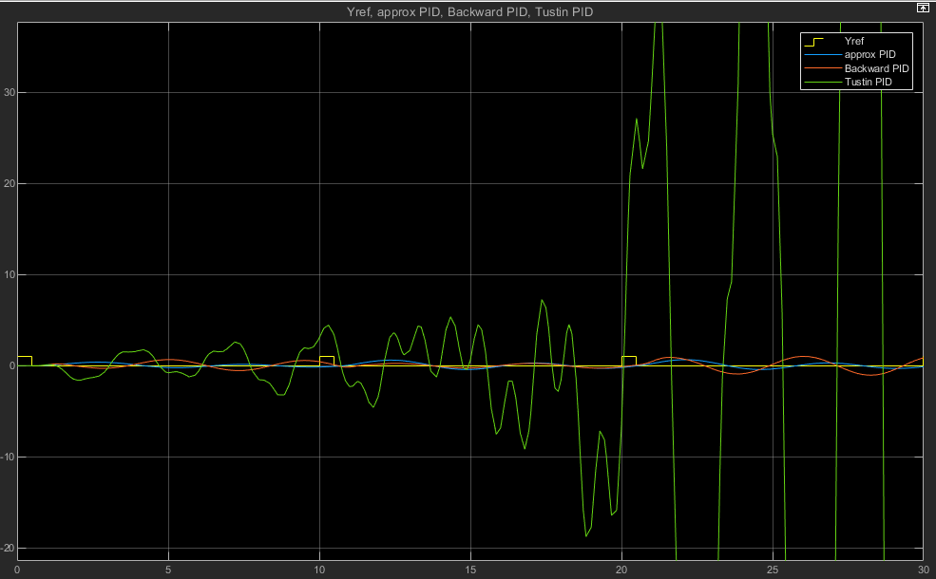

### Sampling time h=0.1

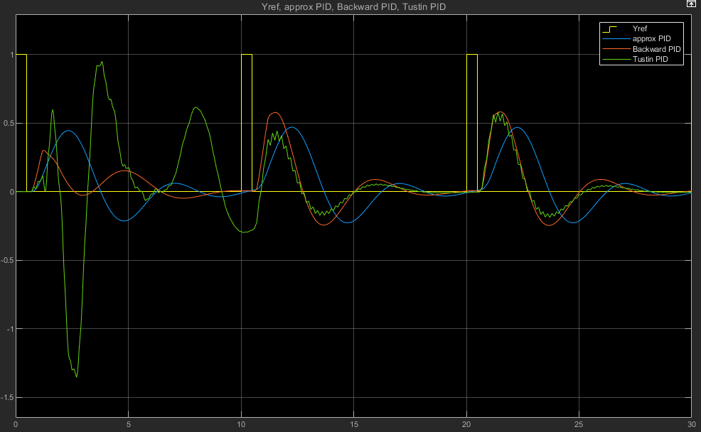

## Step with white noise(power: 0.5):

### Sampling time h=0.5

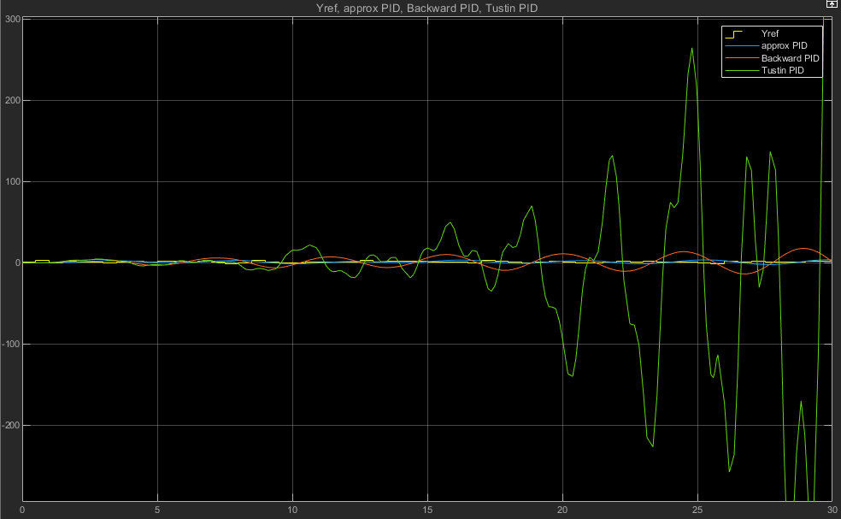

### Sampling time h=0.1

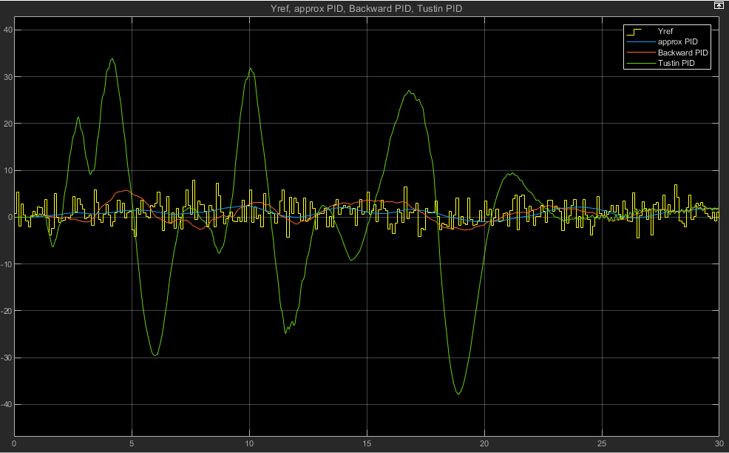

The m-code was basically just 1 line: h=SamplingTime

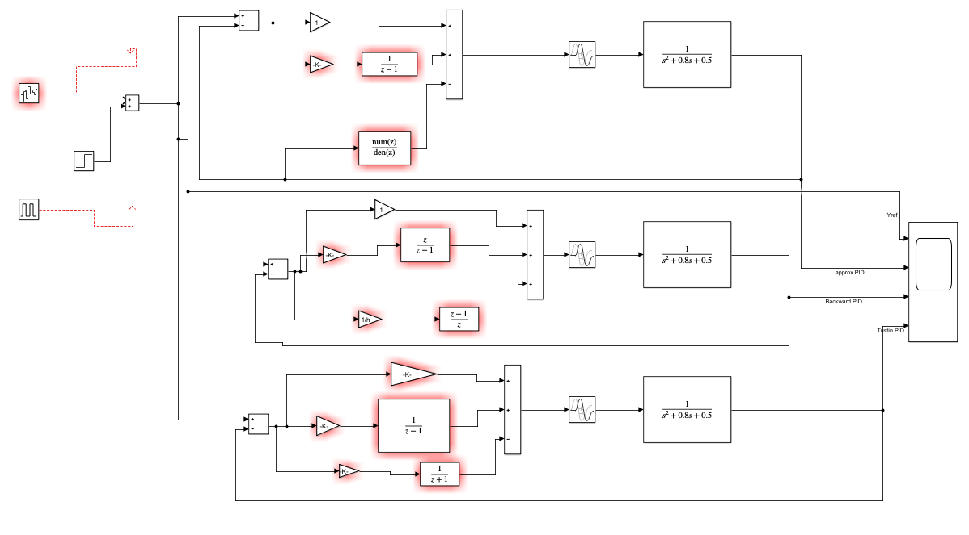My Simulink chart. (Please give feedback if there is a smoother/faster way to do this).